The revised manuscript defines the two quantities separately: video duration is the mouthpiece-to-lip contact interval, whereas FRIENDS duration is the atomizer-activation interval. We retained Pearson correlation as a measure of association and added a Bland–Altman analysis of the 22 paired participant-level mean durations. With differences defined as video minus FRIENDS, the mean bias was +0.53 s and the 95% limits of agreement were −0.44 to +1.48 s. A test for proportional bias (Pearson r between mean and difference) was statistically significant (r = 0.56, p = 0.006), indicating that the video method recorded increasingly longer durations at higher mean values.
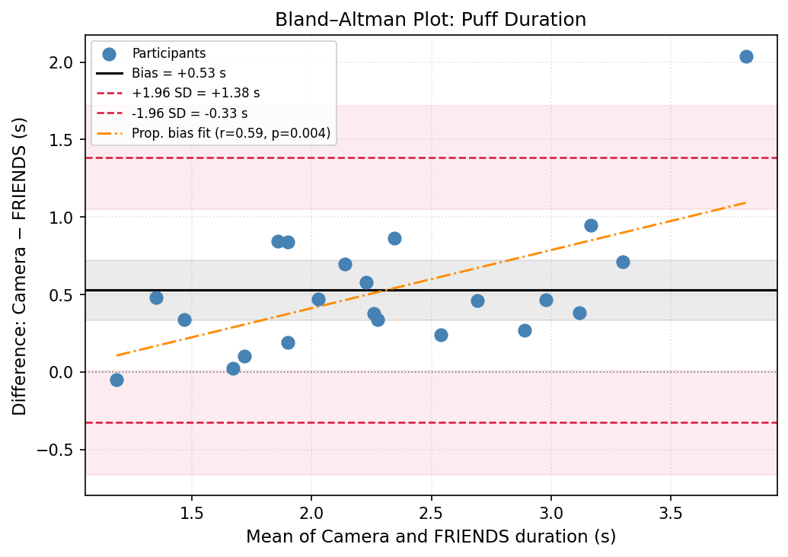
Figure X. Bland–Altman plot comparing video-coded and FRIENDS-recorded puff durations across 22 participants. Each point represents one participant's mean puff duration. The horizontal axis shows the mean of the two methods; the vertical axis shows the difference (video minus FRIENDS). The solid black line indicates the mean bias (+0.53 s); dashed red lines indicate the 95% limits of agreement (−0.33 to +1.38 s); shaded bands represent the 95% confidence intervals around each line. The orange dash-dotted line shows the proportional-bias regression fit (r = 0.59, p = 0.004), indicating that disagreement between methods increases with puff duration.

Distribution of Camera (human-coded) puff durations
Across all 22 participants, human video coders identified 866 "puff lip" events, which constitute the ground truth against which device detections are scored. We characterized the full duration distribution of these 866 camera puffs directly from the video annotation timestamps (Duration_sf field), independent of any device-side processing. The distribution is unimodal and right-skewed: durations range from a minimum of 0.60 s to a maximum of 8.00 s, with a mean of 2.38 s and a median of 2.28 s (SD = 0.96 s). Critically, not a single one of the 866 camera puffs is shorter than the 0.4 s threshold used for the device-side filter (0/866, 0.0%) -- the shortest annotated puff in the entire dataset (0.60 s) is still 50% longer than the threshold.
Statistic | Value
N (camera puffs, all 22 participants) | 866
Minimum duration | 0.60 s
Maximum duration | 8.00 s
Mean duration | 2.38 s
Median duration | 2.28 s
Standard deviation | 0.96 s
5th / 25th percentile | 1.16 s / 1.76 s
75th / 95th percentile | 2.72 s / 4.04 s
Camera puffs < 0.4 s | 0 (0.0%)

The single shortest camera puff in the dataset (0.60 s) occurred in participant FRIENDS2080, who also has the shortest mean puff duration of any participant (1.16 s) and is the only participant with any camera puffs under 1.0 s (15 of the 866 total, all in the 0.60-0.98 s range). Every other participant’s shortest annotated puff is at or above 1.08 s. In other words, even in the single most conservative case in the entire validation set, the human-coded ground truth stays comfortably clear of the 0.4 s cutoff -- the threshold sits below the empirical floor of camera puff durations, not within the body of the distribution.
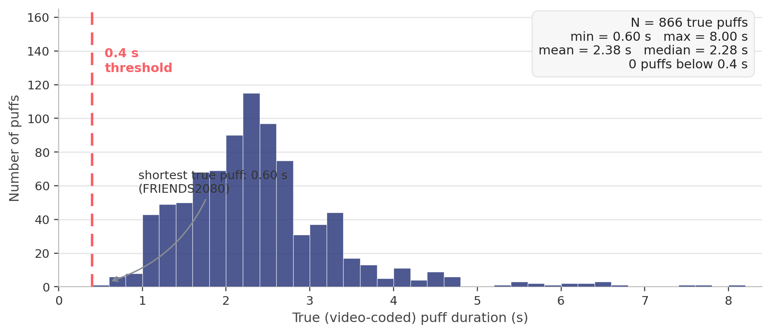
Figure 1. Distribution of all 866 video-coded camera puff durations, all 22 participants. The dashed line marks the 0.4 s device-side filter threshold; the empirical distribution does not begin until 0.60 s, leaving a clear margin between the threshold and the shortest observed camera puff.
Because the 0.4 s filter is applied only to the FRIENDS device event stream (to suppress brief electromagnetic-interference artifacts) and never to the human-coded video annotations, and because the shortest annotated camera puff (0.60 s) already exceeds the filter threshold by a comfortable margin, the threshold has no mechanism by which it could exclude a camera puff from the validation dataset.

Result Description of Human Lab Study with Reconciled Numbers
Video coding identified 866 puffs across the 22 sessions. The FRIENDS device detected 888 puffs in total. Of these, 799 correctly matched a video-coded puff (true positives) and 73 matched no video-coded puff (false positives); the remaining 16 were duplicates, where a single video-coded puff was split into two or three separate FRIENDS detections. Since 799 video-coded puffs were detected and 67 were missed (799 + 67 = 866), the device achieved a mean precision of 91.6% ± 7.2%, recall of 92.3% ± 7.8%, and F1 score of 0.92 ± 0.06 (cluster-robust 95% CI, participant as the sampling unit), with 799 TP, 67 FN, and 73 FP.

